NOAA Fisheries Stellar
Sea Lion Population Count
(2025)
Jasmine Rodelas(826513253), Surinder Singh Chhabra(131727723), Tianna Calderon (132637021)

Abstract- Our project presents an automated pipeline that counts Steller sea lions in satellite imagery using a combination of computer vision techniques and machine learning. The dataset consists of paired training images, one unlabeled while the other is human-labeled with specific colored dots marking each sea lion in the image. To convert the dots into training labels, we preprocessed the images to extract the dot locations by computing pixel-wise differences between the plain and dotted images. We filtered out the noise of the grainy images, addressed the blacked out regions in the labeled images, and classified the dot colors into the five categories of sea lions. To isolate individual dots we utilized color-distance metrics and removed outlier images with a threshold-based filtering so as to not skew the data.
With our extracted dot counts for each image, we trained a ResNet-18 CNN to regress the number of sea lions in each class from the images. We evaluated the model using mean-squared error, mean-absolute error, and per-class error analysis, along with visuals of loss curves and true-versus predicted scatter plots. The results demonstrate that with robust dot extraction and a deep regression model we can estimate Steller sea lion populations, offering an automated alternative to manual counting. This project provides support in the analysis required for sea lion population conservation and monitoring.

- Introduction
Counting and monitoring wildlife populations is essential for conservation, particularly for species such as the Steller sea lion, whose numbers provide important insights into ecosystem health and long-term population trends. NOAA Fisheries collects high-resolution aerial images of rookeries and haul-outs to track these populations, but manually counting sea lions in thousands of satellite images is extremely time-consuming and prone to human error. To address this challenge, our project aims to develop an automated system capable of estimating the number of sea lions in each age and sex class directly from imagery.
The goal of this project is to take NOAA’s aerial photographs and automatically determine how many sea lions are present in each demographic category: adult males, subadult males, adult females, juveniles, and pups. The dataset includes pairs of images: one plain image and one human annotated image that marks each sea lion with a colored dot corresponding to its class. By extracting these dots and converting them into per-image labels, we created a training set suitable for deep learning–based regression.
This task presents several challenges. The images vary widely in lighting and contrast, some include large blacked-out regions, and many of the colored dots are extremely small or visually ambiguous. Additionally, handling the large dataset required careful memory management, limiting the number of images we could process at once. We addressed these issues with color masking, robust dot-extraction methods, and iterative adjustments to our model architecture and data preprocessing pipeline.
With these components in place, our system uses a convolutional neural network to learn the relationship between image features and sea lion counts, providing a scalable alternative to manual population surveys. This automated approach supports NOAA’s broader efforts in conservation monitoring by enabling faster and more consistent population assessments.

- Dataset description
Our data came from the NOAA Fisheries Steller Sea Lion Population Count competition on Kaggle. The full dataset is approximately 95 GB. Due to storage and hardware limitations, we were only able to download all 947 training and “traindotted” images, and a subset of the 2,082 test images. Attempting to work with more than about 300 images at a time consistently caused our computers to crash because of insufficient memory, and our internet connection was also throttled during large uploads and downloads. These constraints influenced the size of the dataset we could practically use for model development and evaluation.
There was also a strong class imbalance due to the nature of ecological population data. The colonies do not contain equal proportions of each biological category. For example, males and subadult males are much less common and appear in smaller numbers in comparison to adult females and pups who tend to aggregate in large groups during breeding seasons
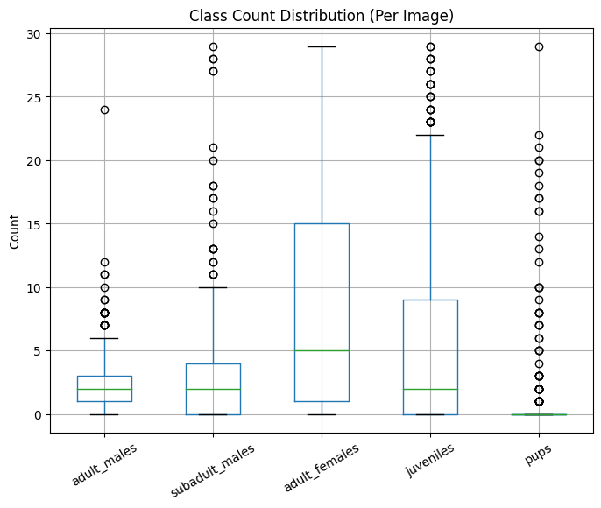
Fig. 1 Representation of the count of classes averaged to show the types we were looking for.

- Experiments
Our primary model for analyzing the images is a convolutional neural network (CNN) using a patch-based regression approach. A CNN breaks an image into many small patches and processes these localized regions separately. This allows the model to focus on fine-scale details and can improve performance when the dataset is relatively small. The network learns from many overlapping patches rather than only from whole images.
We use CNNs because they take advantage of weight sharing and spatial coherence. Weight sharing means the same filter (set of weights) is applied across the entire image, which dramatically reduces the number of parameters the model has to learn. Spatial coherence means nearby pixels tend to be related, so the CNN can detect meaningful patterns like edges and textures. Together, these properties make CNNs more efficient on devices with limited memory and computing power, and they help reduce overfitting by keeping the model size smaller.
Our CNN architecture consists of repeated blocks of Conv2D → MaxPool → Conv2D → MaxPool. The Conv2D layers apply learnable filters that slide across the input image and compute dot products to produce feature maps, which highlight patterns such as edges, textures, and shapes. The MaxPool layers then downsample these feature maps by keeping only the most important activations, reducing the spatial dimensions while preserving key features.
For training, we used 100 images with a batch size of 16 for 5 epochs. The model was trained in Google Colab using an A100 GPU, which significantly accelerated the training process.

model, history = train_model_streaming(
limit_images=100,
batch_size=16, # or 128 if you don't get OOM
val_fraction=0.2,
epochs=5)
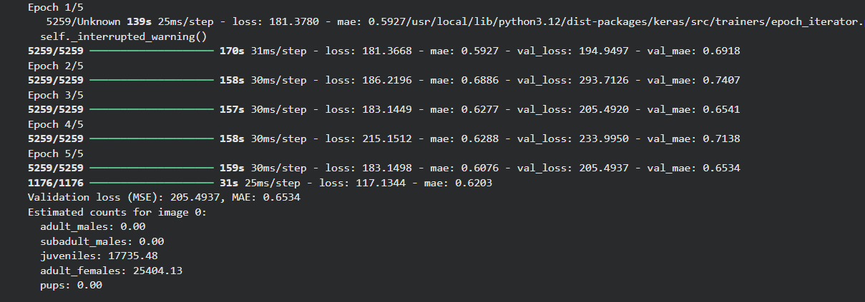
Fig. 2 shows the MSE and MAE for each of the epochs.

Moreover, we also utilized the Kaggle Notebook environment to workaround the issue of storage space for the 95 GB-sized dataset. The notebook runs on a NVIDIA Tesla T4 GPU. As mentioned in the previous section, we were able to train on all 411 training images out of the total 947 for 10 epochs using a 80/20 training and validation split. The dot-extraction pipeline (difference masking, color filtering, connected components analysis) was executed on all images to produce class specific count labels. These labels were then used to train a ResNet-18 CNN for multi output regression. This model was trained using a batch size of 8, and Adam optimizer, and mean squared error (MSE) loss.

- Major challenges and solutions
In our project, we encountered several key challenges: running out of memory on our systems, reliably identifying the animals in the images, and ensuring that our mean squared error (MSE) reflected true model performance. Below, we describe a few of the experiments that led to the most noticeable changes in our results.
In our initial trials, the model struggled to count most of the classes correctly. The prediction plots showed that it was mainly detecting juveniles and adult females, while largely missing the other categories. We improved performance by refining the color range masks used to detect the annotation dots in the images. Our initial color ranges were:

"adult_males": ((0, 70, 50), (10, 255, 255)), # red (low range)
"subadult_males":((140, 50, 50), (170, 255, 255)), # magenta/pink
"juveniles": ((90, 50, 50), (130, 255, 255)), # blue-ish
"adult_females": ((10, 50, 50), (35, 255, 255)), # brown/yellowish
"pups": ((35, 120, 120), (85, 255, 255)), # green-ish

Our current color ranges are

COLOR_RANGES = {
"adult_males": [
((0, 120, 120), (10, 255, 255)), # red low
((170, 120, 120), (179, 255, 255)), # red high (wrap around)
],
"subadult_males": [
((130, 120, 120), (165, 255, 255)), # magenta-ish
],
"juveniles": [
((85, 120, 120), (130, 255, 255)), # a bit wider blue
],
"adult_females": [
((10, 80, 80), (35, 255, 255)), # loosen a bit
],
"pups": [
((35, 80, 80), (85, 255, 255)), # loosen S/V
],
}
We added a wrap-around correction for the red channel because many of the dots (class centers) were not being detected in our initial implementation. This adjustment improved the mean squared error (MSE) to approximately 0.49. However, we still had trouble when plotting predicted versus true counts; the model was not reliably distinguishing certain classes. To address this, we modified the patch size and stride and reduced the number of training epochs. Specifically, we set `max_empty_patches_per_image = 20`, `patch_stride = 16`, `epoch = 1`, and `limit_images = 100`. After these changes, our MSE increased to 1.3258, and the model still failed to correctly identify adult_males and subadult_males, so the true error was likely higher than what our metrics suggested.

We also experimented with increasing contrast in the images to make seals easier for the model to detect. This was implemented in a function called `extract_dot_centers_from_pair`, which emphasized differences between image pairs. However, this modification led to an RMSE of 2663.947. In these runs, the model tended to overcount juveniles, adult females, and pups, while still under-identifying adult males and subadult males. We attempted to correct this by adjusting the loss weights for each class so that adult males and subadult males would be penalized more when misclassified, but these changes did not fully resolve the imbalance.
In addition, we also tried modifying the color ranges to:
REF_COLORS_BGR = {
"adult_males": np.array([ 30, 30, 220], dtype=np.float32), # red
"subadult_males": np.array([235, 10, 235], dtype=np.float32), # magenta / pink
"adult_females": np.array([ 30, 60, 90], dtype=np.float32), # brown
"juveniles": np.array([180, 40, 40], dtype=np.float32), # blue
"pups": np.array([ 40, 180, 40], dtype=np.float32), # green
}
With this modification, we added a more robust isolating dot mask, we were able to get more accurate counts of sea lions per class with less noise or background pixels mistaken for labels. Our function finds all the pixels that are changed between the plain and dotted images by computing the pixel-wise differences and applying a threshold to mark it white if it is distinct enough to be classified as a dot. We then only keep the pixels that fall within our defined range of color labels for each class. The dot mask below shows the colored dots detected by our function in white and below it is the original image with the labeled sea lions.

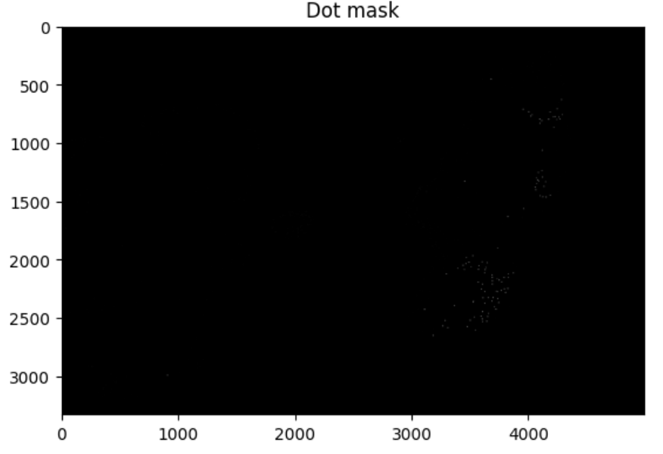
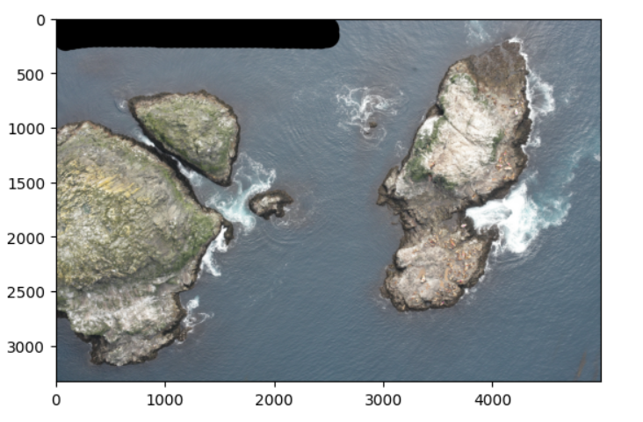
Fig 3. & 4. Shows the mask layer and dotted layer aerial image. (Dots are visible just very small)

Even with our improved dot detection, there were still images that displayed out of range counts for some class. More specifically, the classes that used dots similar in color to the colors of the background like brown, green, and blue. To preserve the quality of the dataset, we set up a threshold to create a cleaned dataset that only included reasonable and expected counts for each class. So from our training dataset of 947 images, we ended up training on 411. From this subset we also addressed the imbalance of true class counts in the images. The average counts of each class from the images are shown below. The imbalance contributed towards the models inaccuracies since classes like pups were harder to count since they are much smaller as opposed to the adults or the class with more distinctive dots that contract against the background.

- Evaluation Metrics
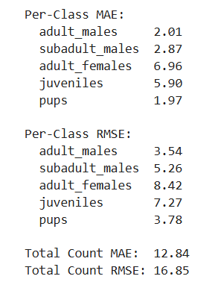
Fig 5. Metrics of MAE and RMSE.

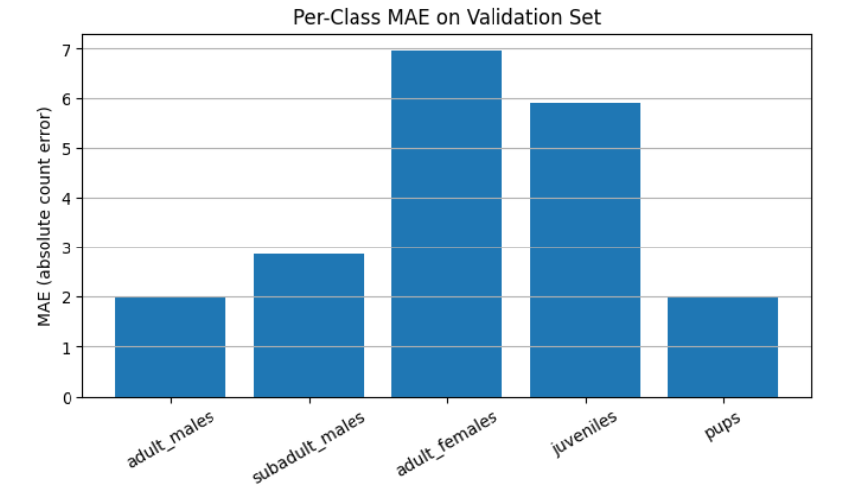
Fig. 6 MAE bar graph for Validation Set
Epochs vs MSE
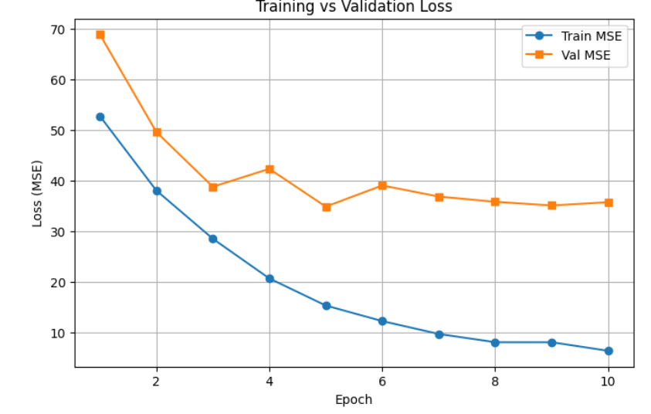
Fig. 7 Training vs. Validation Loss example

Training vs validation loss
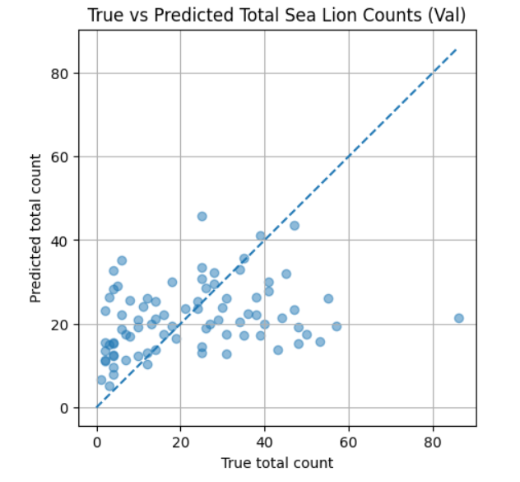
Fig 8. True vs Predicted Total Sea Lion Counts scatter plot.
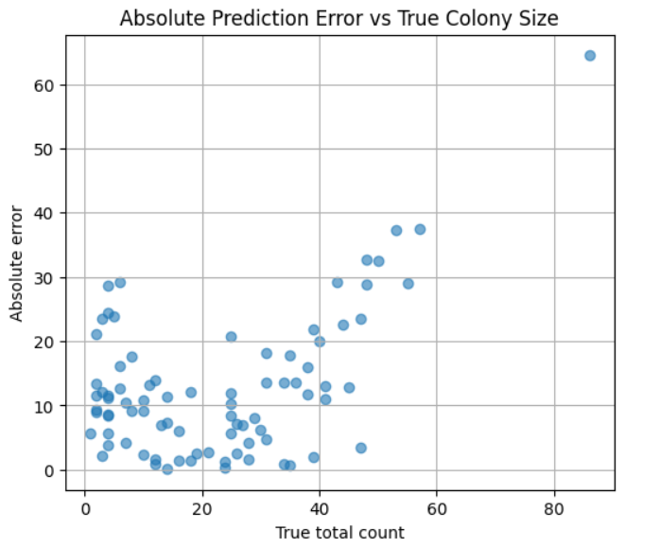
Fig. 9 Absolute Prediction Error vs True Colony Size Scatter Plot.

- Major results

The trained CNN was able to predict sea lions with a reasonable accuracy across the five classes. On the validation set, the model reached a total count RMSE of 16.85 and a total count MAE of 12.84 which indicates that on average the model’s predictions were within about 14 sea lions of the true total count per image. This accuracy is quite promising since there is a naturally high variation amongst colony sizes and the images were quite visually complex aerial imagery. The per class analysis shows that the model achieved its highest accuracy on pups with a MAE = 1.97 and adult males with a MAE = 2.01 which indicates that these groups possessed visual patterns or dot patterns the model can reliably learn. The lowest accuracy was the adult females with an MAE = 6.96 and RMSE = 8.42 which may be attributed to their occlusion patterns in crowded breeding sites.
The loss curve demonstrates stable convergence where the training MSE rapidly drops over the first few epochs which means the learning rate is appropriate and the model is successfully optimizing its parameters. However, the plateau in the validation loss shows that the model reaches its generalization limit and that additional training after 5 epochs does not improve validation performance and the model begins to overfit slightly. The model learns quickly in the early epochs but the accuracy is constrained by the data quality and label noise since it generalizes reasonably well but has limitations.
From the True vs Predicted Total Sea Lion Counts scatter plot we can conclude that the model generally undercounts images with larger colony sizes since most points above ~20 fall below the diagonal line. This may be due to higher density scenes being more rare in the dataset and overlapping animals making counting more difficult. Between 0 and ~30 counts the predictions cluster tighter around the diagonal meaning the model performs better on low and moderate density images where the sea lions are more separate and distinct. We also see that there are no extreme outliers where even the undercounts remain relatively in reasonable range. To emphasize this finding, the Absolute Prediction Error vs True Colony Size graph shows the positive correlation between increases in true total counts and an increase in errors.

- Analysis
The training and validation loss curves reveal several important trends about the model’s learning behavior. The training MSE decreases steadily and significantly across epochs, dropping from nearly 50 to below 6 by epoch 15. This indicates that the model is successfully fitting the training data and learning useful spatial patterns from the image patches. However, the validation MSE remains considerably higher, between 34 and 40 after the first few epochs, and does not follow the same decreasing trend. This widening gap between training and validation loss suggests that the model is beginning to overfit, learning patterns that are too specific to the training set and failing to generalize to unseen images.
The per-class MAE and RMSE metrics further highlight this imbalance. Errors for adult males and subadult males are relatively low compared to other classes, but adult females and juveniles exhibit much higher deviations, with MAEs of 7.34 and 5.33, respectively. This disparity reflects inherent challenges in distinguishing certain categories: adult females and juveniles often appear in large numbers clustered together, and their small size in the aerial images can make visual differentiation difficult. Pups show the lowest overall error, likely because their annotation color is easier to isolate during preprocessing and their appearance is more visually distinct.
The total count MAE of 13.56 and RMSE of 17.04 indicates that while the model captures general population trends, it still struggles to match precise counts. This is consistent with the patch-based regression approach, which estimates density from small regions and can accumulate compounding errors, especially in cluttered scenes. Overall, the performance demonstrates that the pipeline is functional and correctly identifies broad patterns.

- Conclusion and Future works
This project demonstrates a complete end-to-end pipeline for automated counting of Steller sea lions from aerial NOAA imagery. By developing a robust dot-extraction process, handling challenging image artifacts, refining color ranges, and training a ResNet-18 model using a patch-based regression strategy, we were able to produce meaningful predictions for five demographic classes of sea lions. Despite hardware constraints and a reduced training dataset, our model successfully learned to identify and quantify sea lions with moderate accuracy.
The results highlight both the strengths and limitations of our approach. The model performs well on clearer classes with distinct visual or color characteristics but continues to struggle with categories that appear more similar or in dense groupings. The divergence between training and validation loss indicates overfitting, suggesting that additional regularization and more training data are needed for stronger generalization.
Overall, our pipeline provides a scalable alternative to manual counting, demonstrating the potential of machine learning to assist in wildlife population monitoring. While not yet precise enough for deployment in operational settings, our work lays a solid foundation for future improvements

Several avenues can improve the performance, robustness, and scalability of the system:
- Expand the dataset
Our strongest limitation was memory and storage. Accessing the full 95 GB dataset or a larger portion of the training images would significantly improve generalization and reduce overfitting.
- Enhance preprocessing and dot extraction
  - Use adaptive color thresholds or clustering-based color detection (e.g., K-means in HSV space).
  - Apply morphological operations to reduce noise and better isolate annotation dots.
  - Explore deep-learning based semantic segmentation as an alternative to color masking.
- Improve model architecture
  - Replace ResNet-18 with a density-estimation model (e.g., CSRNet or UNet-based crowd-counting networks).
  - Incorporate attention mechanisms to better handle visually crowded scenes.
  - Experiment with multi-task learning, predicting both densities and class presence simultaneously.
- Mitigate overfitting
  - Increase augmentation (cropping, random hue shifts, brightness jitter, gaussian noise).
  - Introduce dropout or weight decay.
  - Use early stopping based on validation loss.
- Refine patch-based inference
  - Test multiple patch sizes and strides.
  - Use an overlapping-patch averaging strategy to reduce boundary inconsistencies.
  - Evaluate full-image regression models for comparison.
- Evaluate spatial distribution patterns
Beyond simple counts, future models could analyze behavior, clustering, and movement which would provide richer ecological insight.
By addressing these directions, future versions of the system could achieve higher accuracy, improved generalization, and the reliability needed for real-world population monitoring efforts.

References
[1] Kaggle. (2017). NOAA Fisheries Steller Sea Lion Population Count [Data set]. Kaggle. https://www.kaggle.com/competitions/noaa-fisheries-steller-sea-lion-population-count

